
KRISHNA CLASSES

WORKSHEET
SUBJECT- MATHS
CHAPTER- Circles

NAME OF STUDENT –
ISSUE DATE –

Level-1
- In the given figure, O is the centre of a circle, AB is a chord and AT is the tangent at A. If ∠AOB = 100°, then calculate ∠BAT.
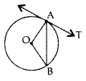
- In the given figure, PA and PB are tangents to the circle with centre O. If ∠APB = 60°, then calculate ∠OAB,
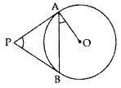
- A chord of a circle of radius 10 cm subtends a right angle at its centre. Calculate the length of the chord (in cm).
- In the given figure, PQ R is a tangent at a point C to a circle with centre O. If AB is a diameter and ∠CAB = 30°. Find ∠PCA.
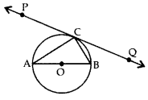
- In the given figure, a circle touches the side DF of AEDF at H and touches ED and EF produced at K&M respectively. If EK = 9 cm, calculate the perimeter of AEDF (in cm).
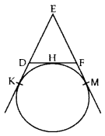
- In the given figure, PA and PB are two tangents drawn from an external point P to a circle with centre C and radius 4 cm. If PA ⊥ PB, then find the length of each tangent.
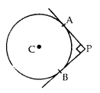
- In the given figure, PA and PB are tangents to the circle with centre O such that ∠APB = 50°. Write the measure of ∠OAB.
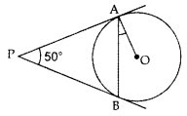
- In the given figure, the sides AB, BC and CA of a triangle ABC touch a circle at P, Q and R respectively. If PA = 4 cm, BP = 3 cm and AC = 11 cm, find the length of BC (in cm).
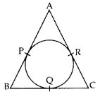
- In a right triangle ABC, right-angled at B, BC = 12 cm and AB = 5 cm. Calculate the radius of the circle inscribed in the triangle (in cm).
- Prove that the tangents drawn at the ends of a diameter of a circle are parallel.
- Two concentric circles are of radii 7 cm and r cm respectively, where r > 7. A chord of the larger circle, of length 48 cm, touches the smaller circle. Find the value of r.
- In the given figure, a circle touches all the four sides of a quadrilateral ABCD whose sides are AB = 6 cm, BC = 9 cm and CD = 8 cm. Find the length of side AD.
- Prove that the parallelogram circumscribing a circle is a rhombus.
- In Figure, a right triangle ABC, circumscribes a circle of radius r. If AB and BC are of lengths 8 cm and 6 cm respectively, find the value of r.
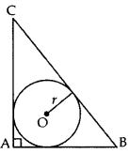
- In the given figure, a circle inscribed in ∆ABC touches its sides AB, BC and AC at points D, E & F K respectively. If AB = 12 cm, BC = 8 cm and AC = 10 cm, then find the lengths of AD, BE and CF.
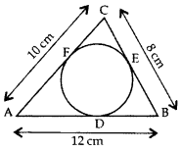

Level-2
- In the figure, a ∆ABC is drawn to circumscribe a circle of radius 3 cm, such that the segments BD and DC are respectively 6 cm 9 cm of lengths 6 cm and 9 cm. If the area of ∆ABC is 54 cm², then find the lengths of sides AB and AC.
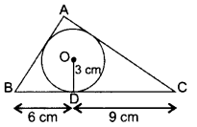
- In Figure, common tangents AB and CD to the two circles with lo, centres O₁ and O₂ intersect at E. Prove that AB = CD.
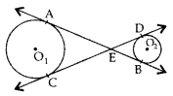
- In the figure, AP and BP are tangents to a circle with centre 0, such that AP = 5 cm and ∠APB = 60°. Find the length of chord AB.
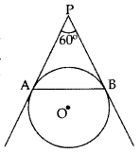
- Prove that opposite sides of a quadrilateral circumscribing a circle subtend supplementary angles at the centre of the circle.
- Two tangents TP and TQ are drawn to a circle with centre O from an external point T. Prove that ∠PTQ = 2∠OPQ.
- Prove that the tangent at any point of a circle is perpendicular to the radius through the point of contact.
- Prove that the lengths of tangents drawn from an external point to a circle are equal.
- 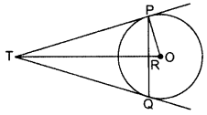
In the above figure, PQ is a chord of length 16 cm, of a circle of radius 10 cm. The tangents at P and Q intersect at a point T. Find the length of TP.
- In the figure, l and m are two parallel tangents to a circle with centre O, touching the circle at A and B respectively. Another tangent at C intersects the line I at D and m at E. Prove that ∠DOE = 90°
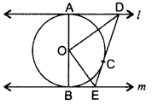
- In the figure, a triangle ABC is drawn to circumscribe a circle of radius 4 cm, such that the segments BD and DC are of lengths 8 cm and 6 cm respectively. Find the sides AB and AC.
